Course list drop down order:
- PALMISTRY
    - Palmistry Diploma Course
    - Advanced Diploma Course in Palmistry
    - Professional Diploma Course in Palmistry
- VEDIC ASTROLOGY
    - Diploma Certification in Vedic Astrology
    - Professional Diploma in Vedic Astrology
- NUMEROLOGY
    - Diploma in Numerology
    - Professional Diploma in Numerology
- VEDIC VASTU
    - Diploma in Vedic Vastu
    - Professional Diploma in Vedic Vastu
- LU SHO GRID
    - Diploma in Lu Sho Grid
    - Professional Diploma in Lu Sho Grid
- TAROT CARD READING
    - Diploma in Course in Tarot card Reading
    - Professional Diploma in Tarot card Reading
- FENGSHUI
    - Diploma in Course in Feng Shui
    - Professional Diploma in Feng Shui
- GRAPHOLOGY
    - Professional Diploma in Graphology
- FACE READING
    - Diploma in Course in Face Reading
    - Professional Diploma in Face Reading

1st Banner:
LEARN PALMISTRY ONLINE
Want to become a Professional Palmist, enroll now to get access to the World’s Best Online Palmistry Training videos at your door steps.

2nd Banner:
LEARN VEDIC ASTROLOGY ONLINE
World’s Best Online Astrology Training videos at your door steps, and become a Professional Astrologer.

3rd Banner:
Combination of all the courses in one slide, which will be the 1st slide actually, lines which will be there as follows:

LEARN PALMISTY, ASTROLOGY, NUMEROLOGY, VASTU IN ASTROWEBGURU ONLINE PLATFORM

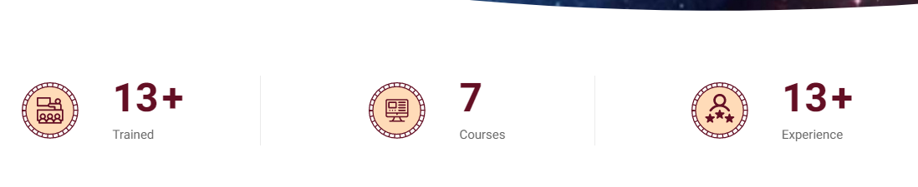
Add 100+ Student in Countries

Possible to add the below like options which will be good, let me know, similar to the above one:


Some pages will have COMING SOON Option in different course list.

IF Possible to enter similar like images then well and good, only in the home page:
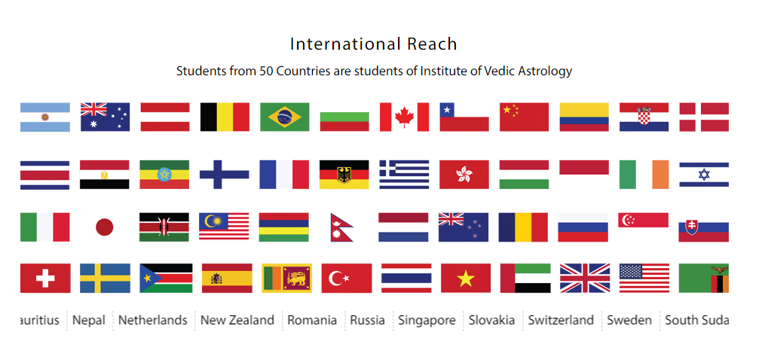
HOW IT WORKS:

Select the course
Select the Course of your choice

Enroll the course
Click on Enroll Now, fill the billing details and proceed to Pay

Connection Medium:
Connect through Pre-recorded courses or One to one course through Zoom or Google meet

Get Certification:
After completion of the course, you will have to pass the test and then get certification and then starts practising.

Testimonials: (Students’ Success Stories):

Please use some videos from the YouTube shorts and some text review from my existing websites.

